**Assingment 3**

1. Why are functions advantageous to have in your programs?

Ans. The function are advantageous to have in a program as it reduces the number of line in code by removing the need to write duplicate code. It make the program easier to read and update. It uses the concept of code Reusability.

1. When does the code in a function run: when it’s specified or when it’s called?

Ans. When the function is called only then the code in a function run.

1. What statement creates a function?

Ans. def is the keyword used to define a function in python

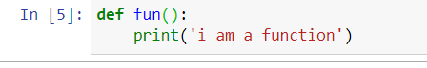

1. What is the difference between a function and a function call?

Ans. Function is the reusable line of code that while function call is the statement in which the curser is transferred to the function because of which function is executed.

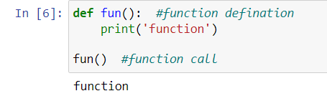

1. How many global scopes are there in a Python program? How many local scopes?

Ans. there is only one global scope in a Python Program. The local scopes are dependent upon the number of function present in a particular program.

1. What happens to variables in a local scope when the function call returns?

Ans. when a function call returns the local scope of that function deleted along with all the variable inside that function.

1. What is the concept of a return value? Is it possible to have a return value in an expression?

Ans. the return value is a way to get the result computed in the function to be used by the main program. Yes the function call can be used inside an expression

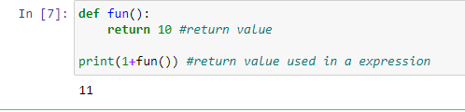

1. If a function does not have a return statement, what is the return value of a call to that function?

Ans. if there is no return value then the function call will return None.

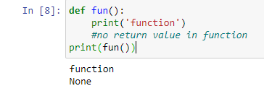

1. How do you make a function variable refer to the global variable?

Ans. with the use of global keyword we can refer to or create global variable inside a function

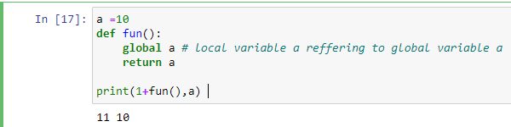

1. What is the data type of None?

Ans. NoneType

1. What does the sentence import areallyourpetsnamederic do?

Ans. the statement will try to import the module areallyourpetsnamederic.

1. If you had a bacon() feature in a spam module, what would you call it after importing spam?

Ans. the bacon() feature then can be called using spam.bacon()

1. What can you do to save a program from crashing if it encounters an error?

Ans. the Try and except block can be used to save program from crashing. The code which expected to be the reason for giving an error should be put inside the try block and the exception handling should be done using the except block

14. What is the purpose of the try clause? What is the purpose of the except clause?

Ans. The code that could potentially cause an error goes in the try clause. The code that executes if an error happens goes in the except clause.